DATA STORAGE TYPES

When it comes to data it is now clear to everyone what the subject of the discussion is: virtual online and offline information of any kind, from photos and videos to documents, downloads and so on.[Data](https://www.webopedia.com/TERM/D/data.html) storage is the containment of any type of information in a particular location. Though today it is typically used to describe storing [applications](https://www.webopedia.com/TERM/A/application.html), [files](https://www.webopedia.com/TERM/F/file.html) and other computing resources, it has existed as long as humans have. Data has been commonly stored and managed by memorizing, carving, writing, recording sound and video, printing type, taping, [programming](https://www.webopedia.com/TERM/P/program.html), creating files and powering [servers](https://www.webopedia.com/TERM/S/server.html).

It is estimated that the world will create 44 [zettabytes](https://www.webopedia.com/TERM/Z/zettabyte.html) of data in 2020; that's 687 billion times larger than

**Data storage** is the storage of information through the use of technologies specifically developed to **store and make it accessible as needed**.

**Data storage** is the use of **recording media to store data using computers** or other devices. **The most common forms of data storage** are **file**storage, **block** storage and object storage, each of them suitable for different purposes.

* **File storage**: Economical and easily structured, data are saved in files and folders. They are usually found on hard drives, which means that they appear exactly the same for the user and on the hard drive.
* **Block storage**: Data are stored in blocks of uniform size. Although more expensive, complex, and less scalable, block storage is ideal for data that needs to be accessed and modified frequently.
* **Object storage**: Data is stored as objects with unique metadata and identifiers. Although, in general, this type of storage is less expensive, objects’ storage is only ideal for data that does not require modification.

Data storage refers to non-volatile storage, i.e. the ability to store information persistently with a reasonable probability that the information will remain unchanged for a reasonable period of time.

**The RAM memory of a computer** is the **typical memory that, on the contrary, is volatile**. In fact, it is sufficient that there is a power failure that all the information stored in it will be lost.

In order **to be able to persistently store information in binary digital format** (bit sequence), it is necessary to have a physical medium with the following characteristics:

* Bit sequences can be written to the device at least once;
* Written bit sequences remain unchanged unless a specific modification operation is performed;
* Bit sequences can be read a large number of times without altering them.

Below we describe some physical media that meet these requirements:

Hard Disk

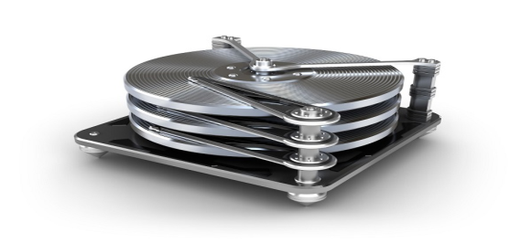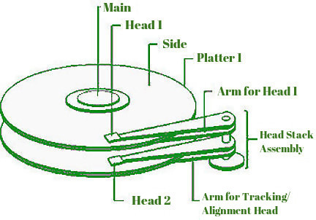

**An**[**Hard Disk Drive**](https://i-recoverydata.com/hard-disk-data-recovery/)(commonly abbreviated as hard disk and abbreviated as HDD, HD), means a mass storage device of **magnetic type** that uses one or more **magnetized disks to store data** (files, programs and operating systems).

**The hard disk is a**[**computer**](https://i-recoverydata.com/usa/desktop-pc-data-recovery/)**storage** device and it is one of the types of mass storage devices currently most used, being present in most computers and also in other electronic devices.

**The hard disk was invented in 1956 by IBM** with the 350 Disk Storage Unit. **The first prototype consisted of 50 disks** with a diameter of 24 inches (about 60 cm) and could store about 5 megabytes of data. It was the size of a refrigerator, weighing over a ton.

**The first PC model produced in 1980**, had a capacity of about 5 MB, a diameter of 5.25 inches and was equipped with a stepper motor, one for the rotation of hard disks and a second for the movement of the heads.

**In 2007 Albert Fert and Peter Grünberg** received the **Nobel Prize for Physics as pioneers of the invention of the modern hard disk**, i.e. with a storage capacity bigger than gigabytes.

The **hard-disk**  basically **consists of one or more fast rotating plates, made of aluminum or glass**, coated with ferromagnetic material and two heads for each disk (one on each side), which, during operation “fly” at a distance of a few tens of nanometers from the surface of the disk reading or writing the data. The head is held up by the air moved by the rotation of the discs whose frequency or speed of rotation can exceed 15,000 rpm; currently the standard values of rotation are 4,200, 5,400, 7,200, 10,000 and 15,000 rpm.

The storage or writing of information or data on the surface of the ferromagnetic support basically consists of the transfer of a certain direction to the magnetization of a certain number of domains.

**In the past, the reading/writing of the magnetic information** was entrusted to inductive heads, miniaturized copper windings capable of detecting, in the reading phase and according to the principle of magnetic induction, the variation of the flux of the **static magnetic field** as the head passes between one bit and the next of a track containing the bits, or in a dual way to **impress a magnetization on the disk** during the writing phase.

**The evolution that Spintronics** has brought to everyone’s homes has been the magneto resistive heads, based on a device, able to vary resistance to the changing of the intensity of the magnetic field. **The advantage given by these heads lies in their sensitivity**, better than the old inductive ones, and in their very small size, which allows to follow the step of the evolutions towards the nanometer as far as the area of a single bit is concerned.

It has long been the only choice on personal computers, but is experiencing a loss of market share in favor of the latest solid state drives, SSD.

Solid State Drive

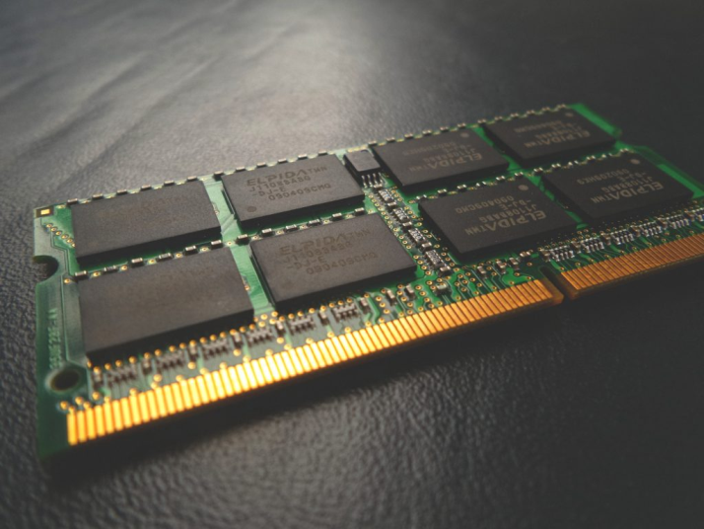

A solid-state drive ([SSD](https://i-recoverydata.com/usa/ssd-data-recovery/)), in electronics and computing, **is a type of semiconductor-based mass storage** device that **uses solid-state memory**(especially flash memory) for data storage.

While the terms “**solid state drive**” or solid state drive are the correct ones, the term “solid state drive” is inappropriate because **there is no magnetic or other type of drive inside the SSD** (in fact, there is no moving component in it). The use of the word “disk” comes from the fact that this type of mass storage device performs the same function as the traditional hard disk and is therefore used, in general, to replace it.

Unlike magnetic media such as the hard disk head, **it has the ability to store large amounts of data in a non-volatile way**, without the use of mechanical parts (plates, heads, motors, etc..) as traditional hard drives do. Most solid state drives use NAND flash memory technology, which allows uniform data distribution and driver “wear”.

An advantageous feature of flash memories is the small physical size, which allows the creation of extremely compact and lightweight SSDs, which can be easily integrated into ultra-thin mobile devices.

DAS: Directly Attached Storage

DAS is a versatile option, and it’s very cool and useful under specific applications. Directly attached storage can be either extremely cheap or expensive, and it has a lot of advantages.

The most basic form of directly attached storage is an external hard drive connected via a USB cable. That’s as simple as it sounds. DAS. A directly attached storage device. However when we talk about storage we tend to mean multiple drives, an array of disks acting together in some way. The DAS concept is the same whether it’s one or 24 drives. Similarly, it’s the same concept regardless if we use a different cable. Actually, USB is much too slow for large DAS units.

DAS. Again simply meaning, we are directly attaching the storage device to the computer without using a network.

**Advantages of DAS: Direct Attached Storage.**

Simpler to setup and configure over NAS / SAN

Cheaper than NAS / SAN in terms of raw storage

Networks not necessary, doesn’t use IP addresses

Faster, more performance and better latency over SAN / NAS

Disadvantages of DAS: Direct Attached Storage

Dedicated resource to a single computer

No economies of scale in sharing the storage

Can’t manage DAS via a network

Requires a special hardware connection

Network Attached Storage

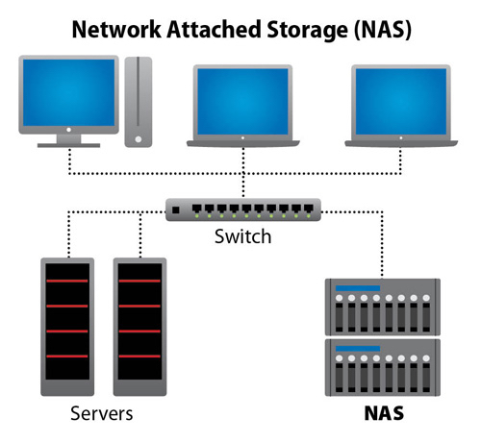

The [NAS](https://i-recoverydata.com/usa/das-san-nas-sds-data-recovery/), Network Attached Storage, **is a special device that allows you to store and share data over a Wi-Fi or wired network with other devices**, such as computers and smartphones. This is because it contains one or more hard disk drives.

In fact, through **a router or a network created by the NAS, it is possible for all connected devices** to access the data stored in the hard-disks.

Network Attached Storage (NAS) is by far the easiest type of storage networking to implement. The simplest way to think of NAS is as a specialized kind of file server

While a file server has a limited supply of storage, NAS storage can provide you with terabytes (TB) of space that is instantly accessible to anyone over a standard Ethernet connection. Compared to a general-purpose server serving files, NAS offers faster data access and easier administration. It also offers:

**· A simpler configuration**Think of it as having to access each individual server to find files, versus having all files in one large NAS pool with a global namespace. This enables anyone to find and open files rapidly.

**· Data manageability** NAS has historically been the preferred means of network storage where data manageability was a higher priority than raw performance. Data manageability was particularly important for those with large files or large numbers of files. However, the advent of SSDs now enables NAS to deliver levels of performance traditionally only available from block-based Storage Area Network (SAN) systems.

**·  Less expensive than SAN** NAS provides a cheaper network storage system than a SAN. According to IDC, file-based data storage accounts for two thirds of the total storage capacity shipped each year. Part of the reason for this is simplicity and the other is cost. By deploying NAS, organizations avoid the need to purchase expensive storage arrays, an extensive Fibre Channel (FC) fabric and import SAN specialists to manage what is a highly technical infrastructure.

**Advantages of NAS: Network Attached Storage.**

Economical way to provide large storage to many persons or computers

Several times easier to setup and configure versus SAN

Easy way to provide RAID redundancy (security) to mass amount of users

Allows users permissions, folder privileges, restricted access to documents, etc

Higher utilization of storage resources

**Disadvantages of NAS: Network Attached Storage**

Requires IP Address(es) and takes up network space

Slower latency and potentially maximum data-transfer issues

Performance can be affected by network status

**Storage Area Network (SAN)**

SAN is a dedicated high-performance network for consolidated block-level storage. The network interconnects storage devices, switches, and hosts. High-end enterprise SANs may also include SAN directors for higher performance and efficient capacity usage.

Servers connect to the SAN fabric using host bus adapters (HBAs). Servers identify the SAN as locally attached storage, so multiple servers can share a storage pool. SANs are not dependent on the LAN and relieves pressure on the local network by offloading data directly from attached servers.

**SAN** is a form of network storage whereby multiple devices are connected to each other and to a server, or cluster of servers. They utilize special switches between devices, which make it possible them to communicate with each other on a network separate from routine Ethernet.

This factor of isolation from other networks makes back-up much simpler and faster The SAN provides the highest performance type of storage network, However, if a SAN sprawls too widely, the enterprise may need to develop [multiple SAN fabrics](https://www.enterprisestorageforum.com/sans/features/article.php/3735451/Storage-Networking-Basics-Understanding-Storage-Routing.htm). SANs, too, are more complex than NAS and DAS. They are also more expensive.

| **NAS** | **SAN** |
| --- | --- |
| **Fabric** | Uses TCP/IP networks, most commonly Ethernet | Runs on high speed Fibre Channel networks |
| **Data processing** | Processes file-based data | Processes block data |
| **Protocols** | Connects directly to an Ethernet network Can use several protocols to connect with servers including NFS, SMB/CIFS, and HTTP | Uses SCSI protocol to communicate with servers |
| **Performance** | Generally has lower throughput and higher latency because of its slower file system layer | A higher performer for environments that need high-speed traffic |
| **Scalability** | Entry level and NAS devices are not highly scalable, High-end NAS systems scale to petabytes using clusters or scale-out nodes | Scalability is a major driver: its network architecture enables admins to scale performance and capacity in scale-up or scale-out configurations |
| **Ease of management** | Easier to manage: device easily plugs into the LAN and offers a simplified management interface | Requires more administration time than NAS |
| **Price** | In general NAS is less expensive to purchase and maintain, although a high-end NAS will cost more than an entry-level SAN | SANs are more complex to manage with FC SANs on top of the complexity heap |

Cloud Storage

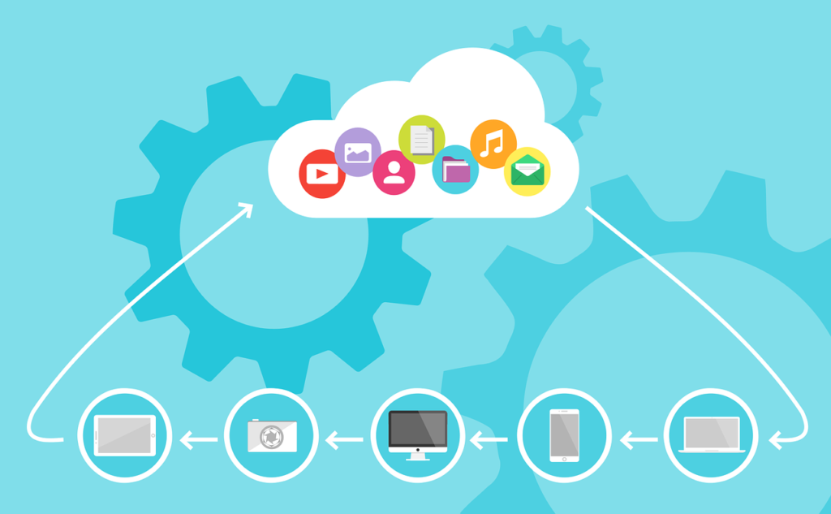

**The definition of cloud storage also analyses the meaning of cloud computing**, so to understand what it is you must first clarify this term: **cloud computing is the use of computing resources** available **on demand** through the Internet, including data **processing and transmission services**; specifically, cloud storage is the use of cloud computing for storing files.

Cloud storage is therefore the most widespread technology of cloud computing, thanks to the spread of useful services for the end user.

**Cloud Storage is a model of data storage on networked computers** where the data itself is stored on multiple virtual servers generally hosted in third-party facilities or on dedicated servers.

Consumers and businesses only pay for the use they make of it, typically a monthly use. This does not mean that cloud storage is cheaper than a hard disk or USB stick, it just means that it consists of operating expenses instead of capital expenditures. In practice, cloud storage is a pure service while using your own means of storage requires expenditure on material goods.

Cloud storage allows you to increase file security and reliability in a single service that stores and encrypts all files on a PC.

Many companies offer free plans for cloud data storage.

However, in terms of size, functionality, management capabilities and service level assurance, free services are often too limited for business use, which may have specific needs depending on the type of use.

Therefore, **it is very often recommended for professional business use to purchase cloud storage services** that offer more storage space and additional security services.

## 

## Types of Cloud Storage

There are three types of [cloud storage](https://aws.amazon.com/what-is-cloud-storage/): Object, File, and Block. Each offers their own unique advantages.

1. Object Storage - Applications developed in the cloud often take advantage of object storage's vast scalability and metadata characteristics. Object storage solutions like [Amazon Simple Storage Service (Amazon S3)](https://aws.amazon.com/s3/) are ideal for building modern applications from scratch that require scale and flexibility, and can also be used to import existing data stores for analytics, backup, or archive.

2. File Storage - Many applications need to access shared files and require a file system. This type of storage is often supported with a Network Attached Storage (NAS) server. File storage solutions like [Amazon Elastic File System (EFS)](https://aws.amazon.com/efs/), [Amazon FSx for Windows File Server](https://aws.amazon.com/fsx/windows/), and Amazon FSx for Lustre are ideal for use cases like large content repositories, development environments, media stores, user home directories, and [Amazon FSx for Lustre](https://aws.amazon.com/fsx/windows/) is ideal for high-performance computing and machine learning workloads.

3. Block Storage - Other enterprise applications like databases or ERP systems often require dedicated, low latency storage for each host. This is analogous to direct-attached storage (DAS) or a Storage Area Network (SAN). Block-based cloud storage solutions like [Amazon Elastic Block Store (EBS)](https://aws.amazon.com/ebs/) are provisioned with each virtual server and offer the ultra-low latency required for high performance workloads.